AP Human Geography Name: ____________________________
Thematic Maps Notes

Reference vs. Thematic Maps
- Reference maps are maps that show where something is in space. Their purpose is to display geographical data (landforms, coastlines, waterways, etc.) and political data (political boundaries, settlements, transportation networks, etc.) for their own sake.
- Thematic maps are maps that tell a story about a place. Thematic maps display the same geographical or political data shown on general maps as a base layer but then map some physical, economic, or cultural phenomenon or top of that base layer. That phenomenon (i.e. climate, crop distribution, religious affiliations, deforestation, population density, TV reception--the list is endless) is the theme of a thematic map and the story that particular map is telling.
TAKEAWAY: _________________________________________________________________
___________________________________________________________________________
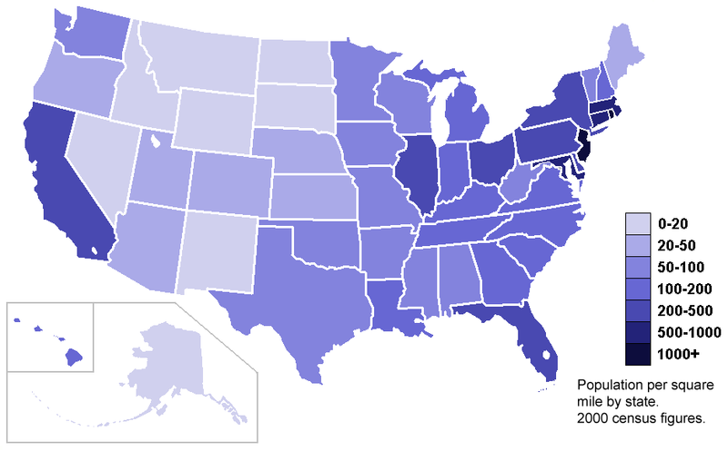
Types of Thematic Maps
A. Choropleth Maps
- Definition: Maps with areas shaded or patterned in proportion to the measurement of the statistical variable.
- Most common type of thematic map because data is commonly reported by political entities with defined boundaries.
- Interval types: Equal number, equal interval, and natural break (aka Jenk's Formula).
- Advantage: Choropleth maps make it easy to visualize how a phenomenon varies over an area (population density varying over the area of the United States in the above map).
- Disadvantage #1: Choropleth maps give a false impression of an abrupt change at the boundaries of shaded areas.
- Disadvantage #2: The category groupings on a choropleth map can be misleading (either intentionally or unintentionally).
- Disadvantage #3: Choropleth maps do not show the exact location of phenomenon within any shaded area. Because of this, choropleth maps suffer terribly from the problem of induction, whereby more information is represented on a map than is actually supplied by the original data. For example, because the above map does not display how population density varies within Texas, it suggests that population density is uniform within the state.
TAKEAWAY: _________________________________________________________________
___________________________________________________________________________
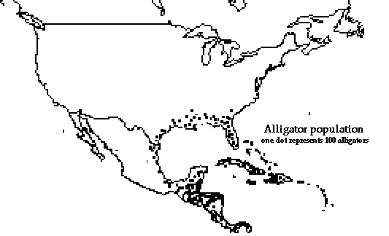
B. Dot Distribution Maps
- Definition: Maps that use dot symbols to show the presence or quantity of a phenomenon.
- Advantage #1: Unlike choropleth maps, dot distribution maps can (but don't always) show the exact location of a phenomenon.
- Advantage #2: Dot distribution maps are good at showing patterns of density.
- Disadvantage #1: When dots get too dense these maps become difficult to read.
- Disadvantage #2: To overcome disadvantage #1, cartographers make each dot represent more than one instance of a phenomenon. But then the dots may be placed randomly so that there may be no actual phenomenon where the dots are located. In the above map for example each dot represents 100 alligators but no single dot gives the location of any actual alligators.
TAKEAWAY: _________________________________________________________________
___________________________________________________________________________
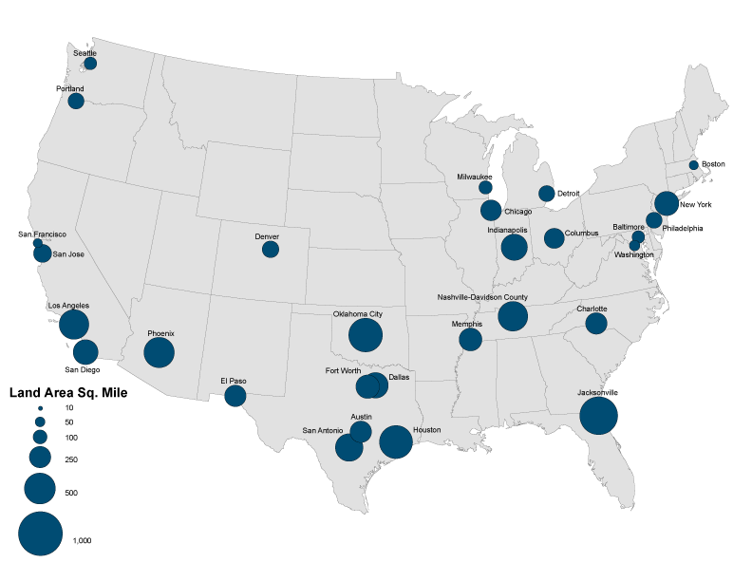
C. Proportional Symbol Maps (aka Graduated Circle Maps)
- Definition: Maps that use symbols (usually circles) that are scaled proportionally to the value of a phenomenon and can be (but are not always) placed where the phenomenon occurs.
- Advantage: Good proportional symbol maps can show both where a phenomenon occurs (like a dot distribution map) as well as the intensity of a phenomenon (like a choropleth map). Note: Choropleth maps show the intensity of a phenomenon with color or shading while proportional symbol maps show intensity through the size of their symbols.
- Disadvantage #1: Proportional symbol maps often don't show exact locations of phenomenon and therefore do not show density patterns well. (The above map of size of U.S. cities actually does show exact locations.)
- Disadvantage #2: Proportional symbol maps suffer from a perceptual problem: The human eye has difficulty perceiving the relative sizes of circles and other symbols. For example, can a viewer really perceive that one circle is exactly twice the size of another?
TAKEAWAY: _________________________________________________________________
___________________________________________________________________________
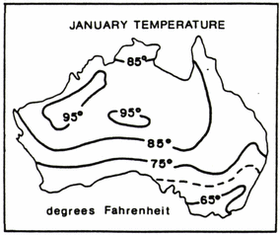
D. Isoline Maps (aka Isopleth Maps)
- Definition: Maps that show lines that join points of equal value. (For example, a topographic map is an isoline map on which lines join points of equal elevation.)
- Advantage: Isoline maps are good at mapping phenomenon that exist at every point but vary gradually over space (i.e. temperature, altitude, pollution, precipitation, etc.)
- Disadvantage #1: Cartographers need huge amounts of data to make accurate isoline maps.
- Disadvantage #2: If the data is "patchy" you end up with isoline maps with lots of little ovals that are difficult to read.
- Disadvantage #3: The fewer data points used to draw the lines on a isoline map, the more that map will suffer from the problem of induction, whereby more information is represented by those lines than is actually supplied by the original data
TAKEAWAY: _________________________________________________________________
___________________________________________________________________________
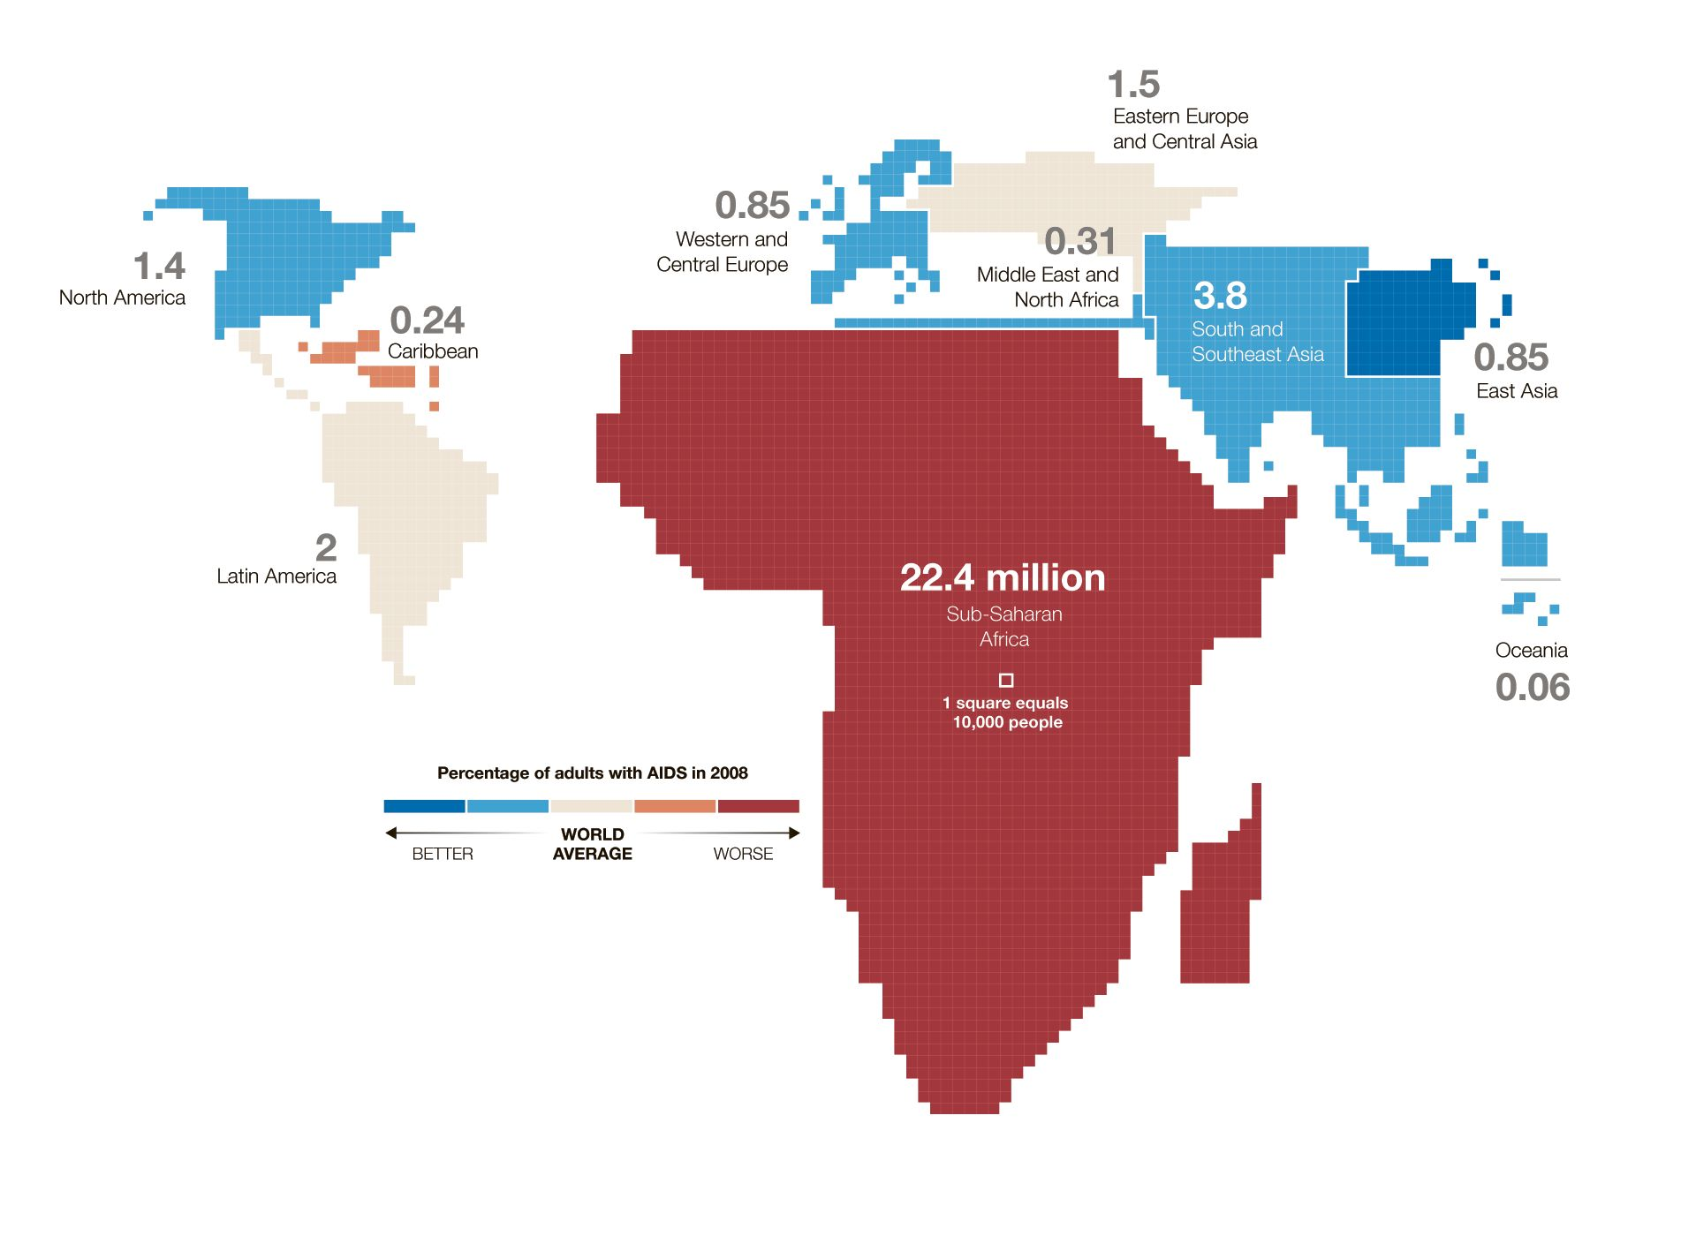
E. Cartograms
- Definition: Cartograms are maps in which the geometry or size of a region is distorted in order to convey some variable.
- Advantage #1: Cartograms make a strong impact and usually are easy to understand.
- Advantage #2: Cartograms solve the classification/interval problem of choropleth maps because areas on the map can be distorted continuously.
% of adults
with AIDS
- Disadvantage: Cartograms suffer from the same perceptual problem as proportional symbol maps, namely, that the human eye had difficulty judging the relative size of objects.
TAKEAWAY: _________________________________________________________________
___________________________________________________________________________

NOTES:

